**AI Assignment report**

Algorithms measured by summing the total distance between all colours and then dividing by total number of colours.

**Constructive heuristic**

100:

0.1833400219295337

0.020943880081176758 seconds



500:

0.1063649391344048

0.4837076663970947s seconds



**Multi Start Hill Climber**

The inversion operator is the better mutation algorithm …bunch of shit

100:

0. 3223631038902211

1.207803726196289s

1000 iterations



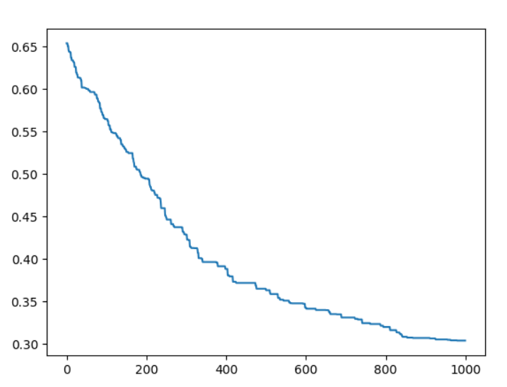

500:

0.47484052853844516

6.915482521057129s

1000 iterations

